# High Impact Skills Development Program

# in Artificial Intelligence, Data Science, and Blockchain

**NAME: Saqib Hussain**

**Roll No: GLT-DSAI-032**

**Section: 01**

**Project Title: Visualization**

Introduction about Dataset:

The dataset is to be related to video game sales across different regions which have16598rows and 11 columns. Here's a description of the columns in the dataset:

1. **Rank**: The ranking of the game based on global sales.
2. **Name**: The title of the video game.
3. **Platform**: The gaming console or platform on which the game was released (e.g., Wii, NES, DS).
4. **Year**: The year the game was released.
5. **Genre**: The genre of the video game (e.g., Sports, Platform, Role-Play).
6. **Publisher**: The company that published the video game (e.g., Nintendo, Microsoft).
7. **NA_Sales**: Sales in North America (in millions of units).
8. **EU_Sales**: Sales in Europe (in millions of units).
9. **JP_Sales**: Sales in Japan (in millions of units).
10. **Other_Sales**: Sales in other regions (in millions of units).
11. **Global_Sales**: Total global sales (in millions of units).

The dataset seems to provide an overview of video game sales across different regions and platforms, with a focus on comparing sales data for each game.

First I create parameters, that’s are "Start Date," "End Date," and "Zone Sales" likely serve the following purposes:

* **Start Date and End Date:** These parameters enable users to analyze sales data within a whicspecific time frame. This is useful for tracking trends over time, comparing sales performance during different periods, or identifying seasonal patterns.
* **Zone Sales:** This parameter might be used to segment sales data by geographical region or zone. This could be helpful for understanding regional variations in sales, identifying high-performing markets, or assessing the effectiveness of marketing campaigns in different areas.

By providing these parameters, the dashboard allows users to tailor the analysis to their specific questions and interests, making it a more valuable and informative tool.

Then I created a calculated field that sums up the sales from all regions or genres for a given year or period, which I defined as 'zone sales'.

There are some sheets that provide useful information.

**Sales by Years and Genra:**

**Graph Type:** Stacked Area Chart

**Information Gained:**

This graph provides a visual representation of video game sales trends over time, segmented by genre. It allows us:

* **Observe overall sales trends:** See how the total sales volume has changed over the years.
* **Compare genre popularity:** Analyze the relative popularity of different genres and how their contributions to overall sales have evolved.
* **Identify peak periods:** Determine the years or decades when specific genres or the industry as a whole experienced significant growth.
* **Analyze genre shifts:** Understand how the popularity of different genres has shifted over time.

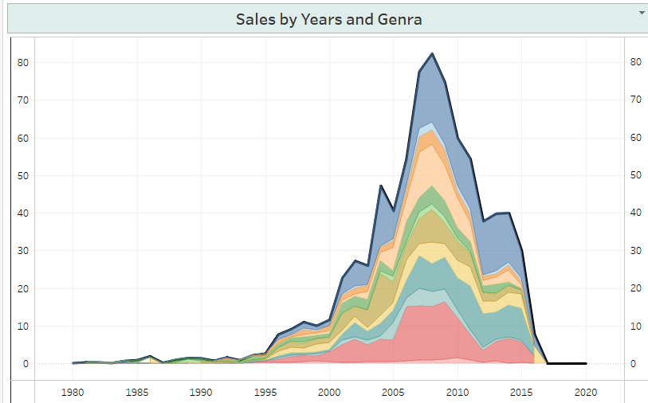

**Top 10 Names by sales:**

**Graph Type:** Horizontal Bar Chart

**Information Gained:**

This graph provides a ranking of the top 10 best-selling video games based on the "Zone sales" metric. It allows you to:

* **Identify the most popular games:** See which games have achieved the highest sales within the specified "Zone sales" criteria.
* **Compare sales performance:** Compare the sales of different games and understand how they rank relative to each other.
* **Analyze game popularity:** Gain insights into the factors that contribute to a game's commercial success.

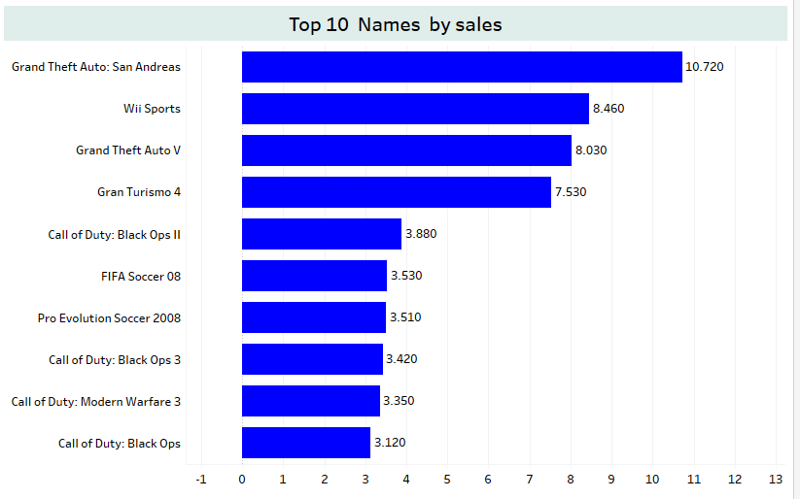

**Top 10 Publisher by sales:**

**Graph Type:** Treemap

**Information Gained:**

This treemap provides a visual representation of the top 10 video game publishers based on their sales within the specified "Zone sales" criteria. It allows you to:

* **Compare publisher market share:** Analyze the relative size of each publisher's market share within the top 10.
* **Identify dominant publishers:** Determine which publishers have achieved the highest sales and dominate the market.
* **Analyze publisher performance:** Compare the performance of different publishers and understand their relative strengths and weaknesses.

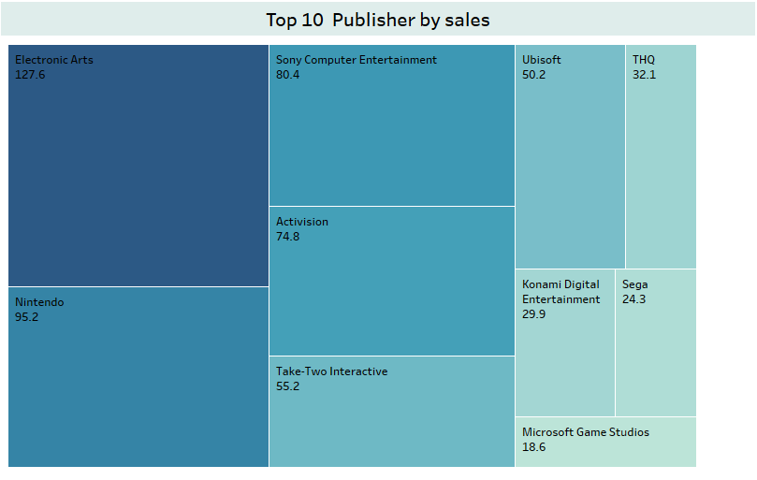

**Top 10 platforms by sales:**

**Graph Type:** Bubble Chart

**Information Gained:**

This bubble chart provides a visual representation of the top 10 video game platforms based on their sales within the specified "Zone sales" criteria. It allows you to:

* **Compare platform market share:** Analyze the relative size of each platform's market share within the top 10.
* **Identify dominant platforms:** Determine which platforms have achieved the highest sales and dominate the market.
* **Analyze platform performance:** Compare the performance of different platforms and understand their relative strengths and weaknesses.

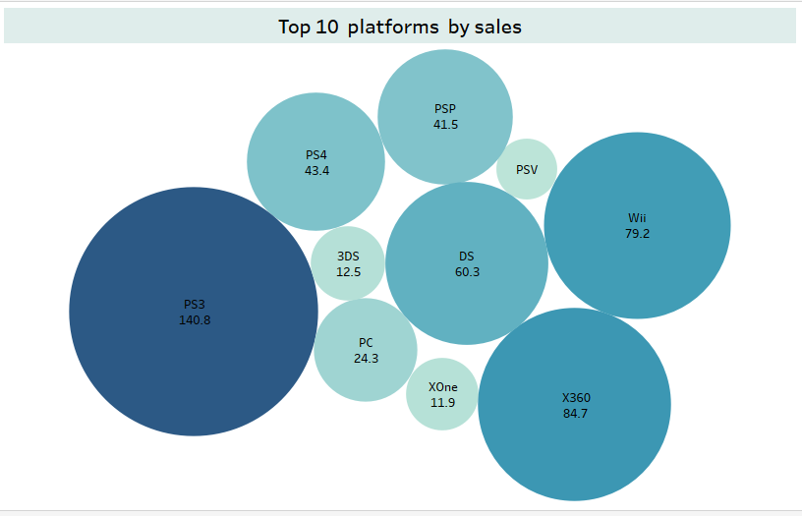

**Total sales by genre:**

**Graph Type:** Bar Chart

**Information Gained:**

This bar chart provides a ranking of different video game genres based on their total sales within the specified "Zone sales" criteria. It allows you to:

* **Compare genre popularity:** Analyze the relative popularity of different genres and understand their market share.
* **Identify dominant genres:** Determine which genres have achieved the highest sales and dominate the market.
* **Analyze genre performance:** Compare the performance of different genres and understand their relative strengths and weaknesses

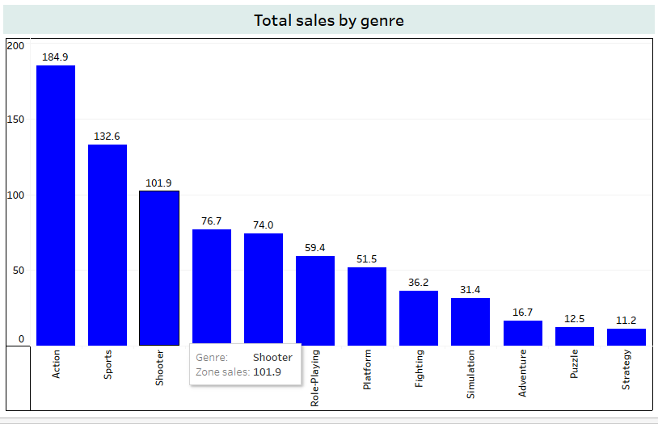

## **Analyzing the Tableau Dashboard:**

**Overview:**

This dashboard provides a comprehensive overview of video game sales data, focusing on key metrics such as genre popularity, platform performance, and publisher market share. It includes several visualizations that allow users to explore and analyze the data in different ways.

**Key Visualizations:**

1. **Total Sales by Genre:** A bar chart that ranks different genres based on their total sales.
2. **Sales by Years and Genra:** A stacked area chart that shows how sales have changed over time for different genres.
3. **Top 10 Names by Sales:** A horizontal bar chart that ranks the top-selling games.
4. **Top 10 Platforms by Sales:** A bubble chart that compares the performance of different gaming platforms.
5. **Top 10 Publisher by Sales:** A treemap that shows the market share of the top-selling publishers.

**Additional Information:**

* **Filters:** The dashboard includes filters for "Genre," "Zone Sales," "Start Date," and "End Date," allowing users to customize the analysis.
* **Metrics:** Various metrics are displayed, such as the total number of games, platforms, publishers, and genres in the dataset.
* **Parameters:** The dashboard uses parameters to control the start and end dates for the analysis.

**Insights:**

By analyzing these visualizations, users can gain insights into:

* **Genre popularity:** Which genres are the most successful in terms of sales.
* **Sales trends:** How sales have changed over time for different genres and platforms.
* **Platform performance:** Which platforms are the most popular and have the highest market share.

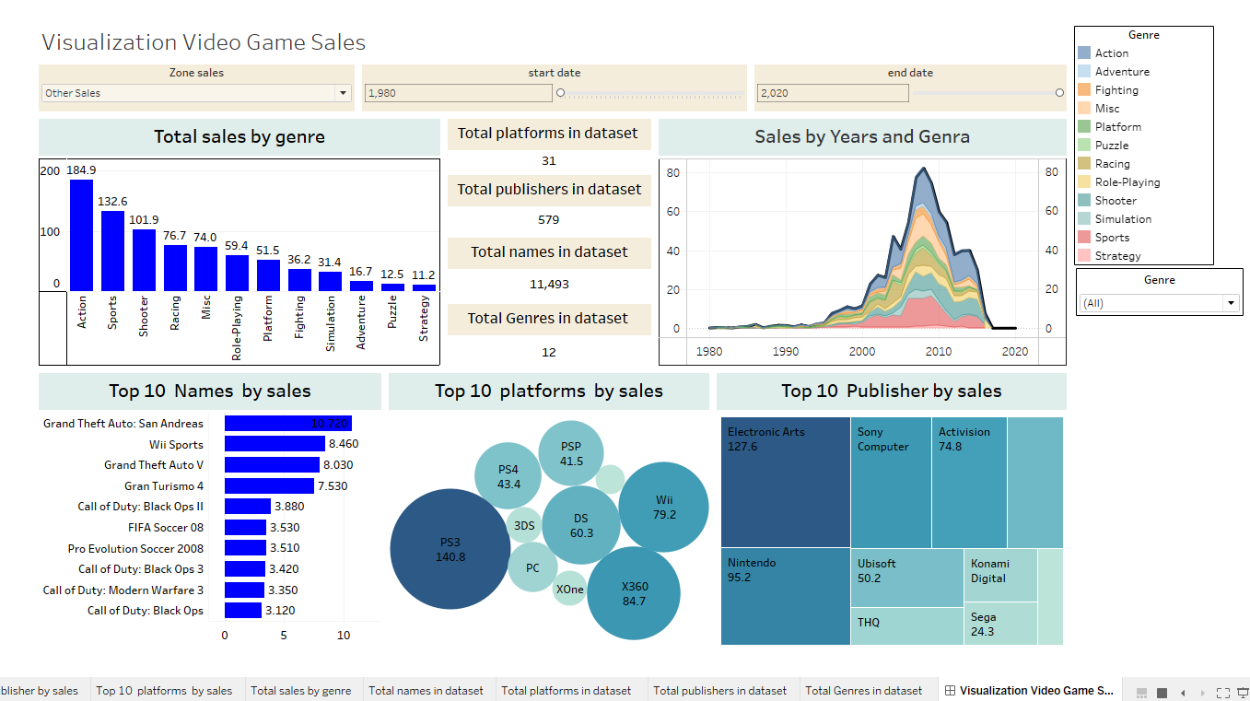

Tableau public link: <https://public.tableau.com/authoring/visualizationvediogamesales/VisualizationVideoGameSales#1>